Project

Scott Letkeman

April 25, 2021

ISyE 6420 – Bayesian Statistics

Comparing the Bayesian and Least squares approaches to multiple Linear Regression

In this paper I will go through some of the standard practices one might go through to build a linear regression model using R, and then develop a similar Bayesian model in Winbugs so that I can compare the results. Finally, I will go into how one could do both things in Python.

The [dataset](https://www.kaggle.com/kumarajarshi/life-expectancy-who) that I have chosen to work with is World Health Organization data that includes life expectancy per country, per year for each year between 2000 and 2015. The other columns include such things as GDP, prevalence of several diseases, expenditures on health care, education rates, etc. In total there were 18 possible numeric parameters.

I used R for parameter selection and development of a traditional linear model based on the least squares method. The first model, included all of the parameters and yielded the following summary:

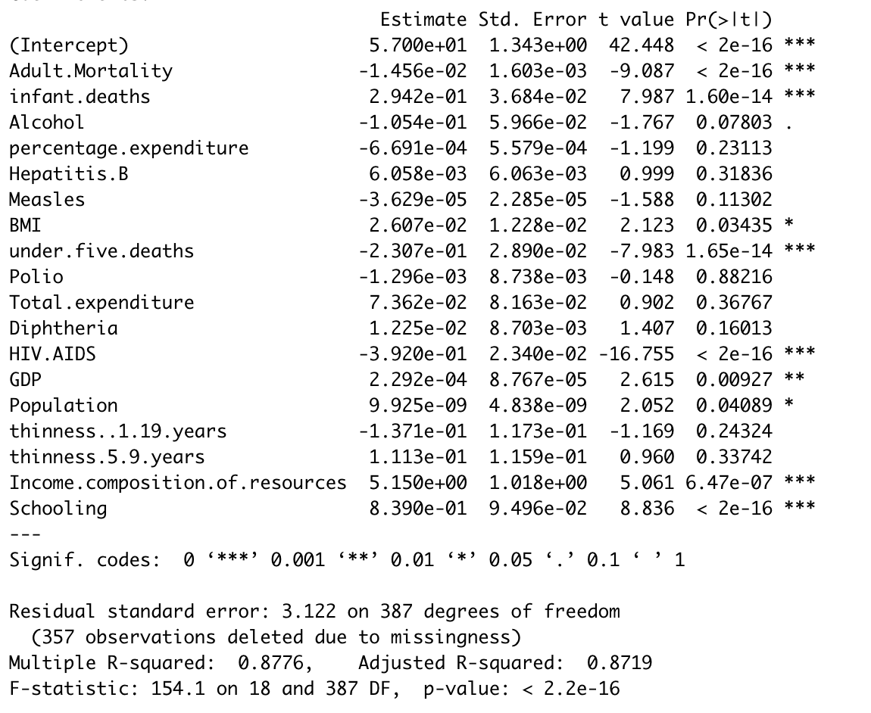

The R2 value is very high at 0.8776 which means nearly 88% of the variability in life expectancy can be explained by this data. Unfortunately, several of the parameters are not significant as indicated by the asterisks to the right of the coefficients. I was aware that several of the parameters were also highly corelated with each other as indicated by this correlation plot. (available with my submission, corr_plot.png)

After removing the insignificant parameters and some that were unnecessary because they were correlated with other parameters, I settled on the following model:

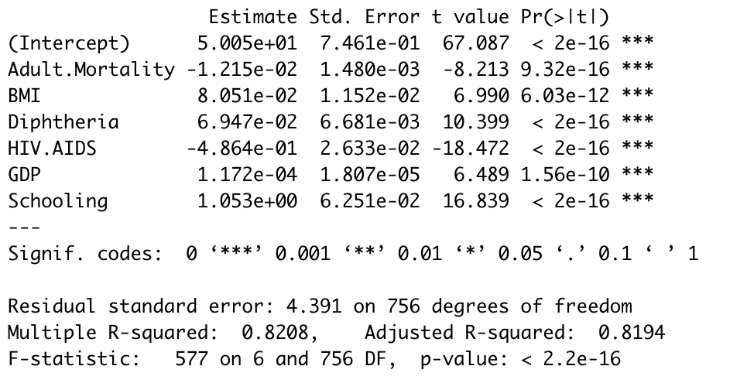

This model managers to explain 82% of the variability in life expectancy using only six parameters. It’s also very easily explained. The baseline life expectancy is 50 years as indicated by the intercept. Adult Mortality is the number of people per thousand between 15 and 60 who are likely to die in a given year and has a negative effect on life expectancy. BMI is body mass index and has a positive impact. Diphtheria is actually the vaccination rate against diptheria as indicated by the positive effect it has. HIV/AIDS is the deaths per 1000 people and has a very negative impact on life expectancy. GDP is an economic indicator that has a positive effect. Finally, Schooling is average number of years of school completed and it has a nearly 1 to 1 positive effect on life expectancy. That is, for every one year increase this rate a country can achieve it results in a one year increase in life expectancy.

The next step is to test the performance of this model. I was trained on rows from before 2004 and I will test it on the later rows. Predicting life expectancies and plotting them against the actual values yields the following:

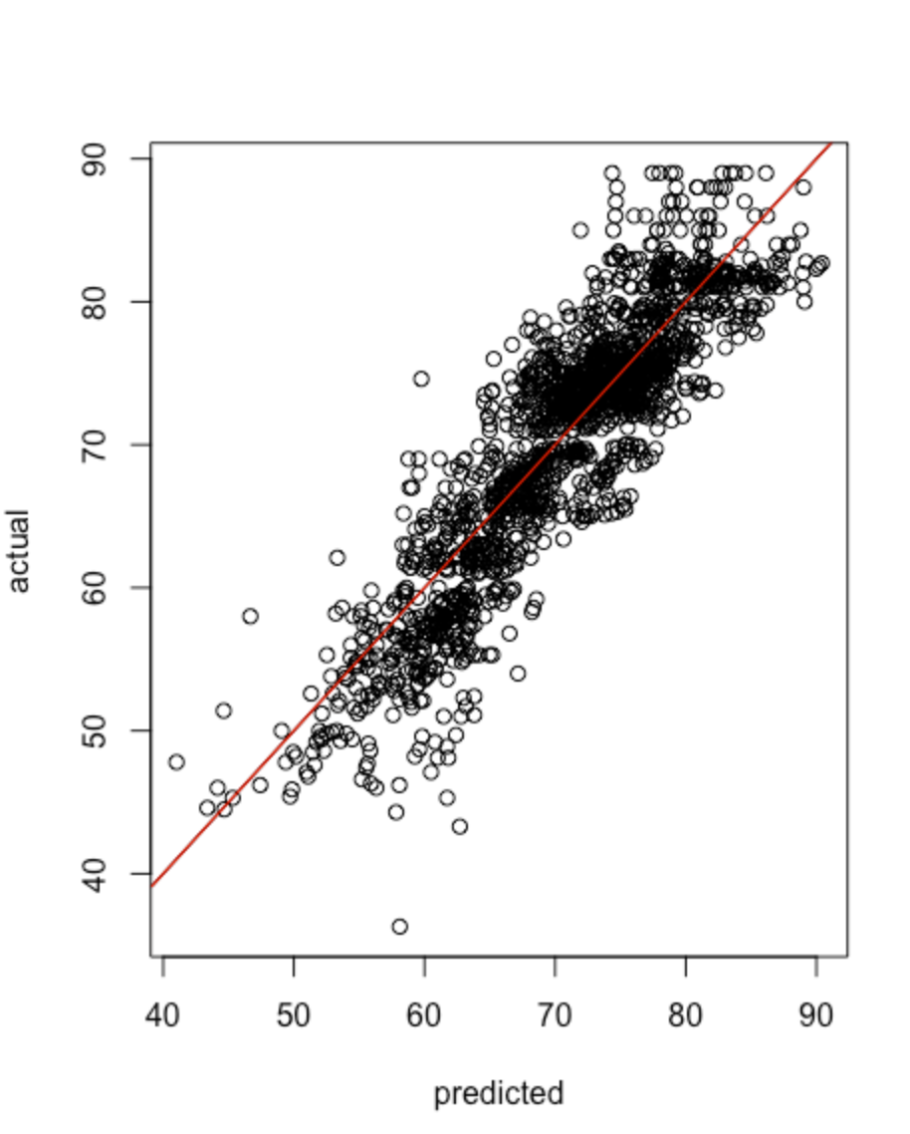

If the data fit the model perfectly without any error, the points land exactly on the line. Clearly my results are decent as the points follow the line fairly closely. The mean squared error comes out to be 17.68.